Linux Fundamentals
================================================================
Submitted to Vikul_Sir
Submitted by Nalathati Rahul
Submission Date –03/Feb/2026
================================================================
L1 - In EC2 Ubuntu Instance Create a new user and SSH Key pair with an authorized key
Step:1 login into AWS console using credentials and go to EC2 service
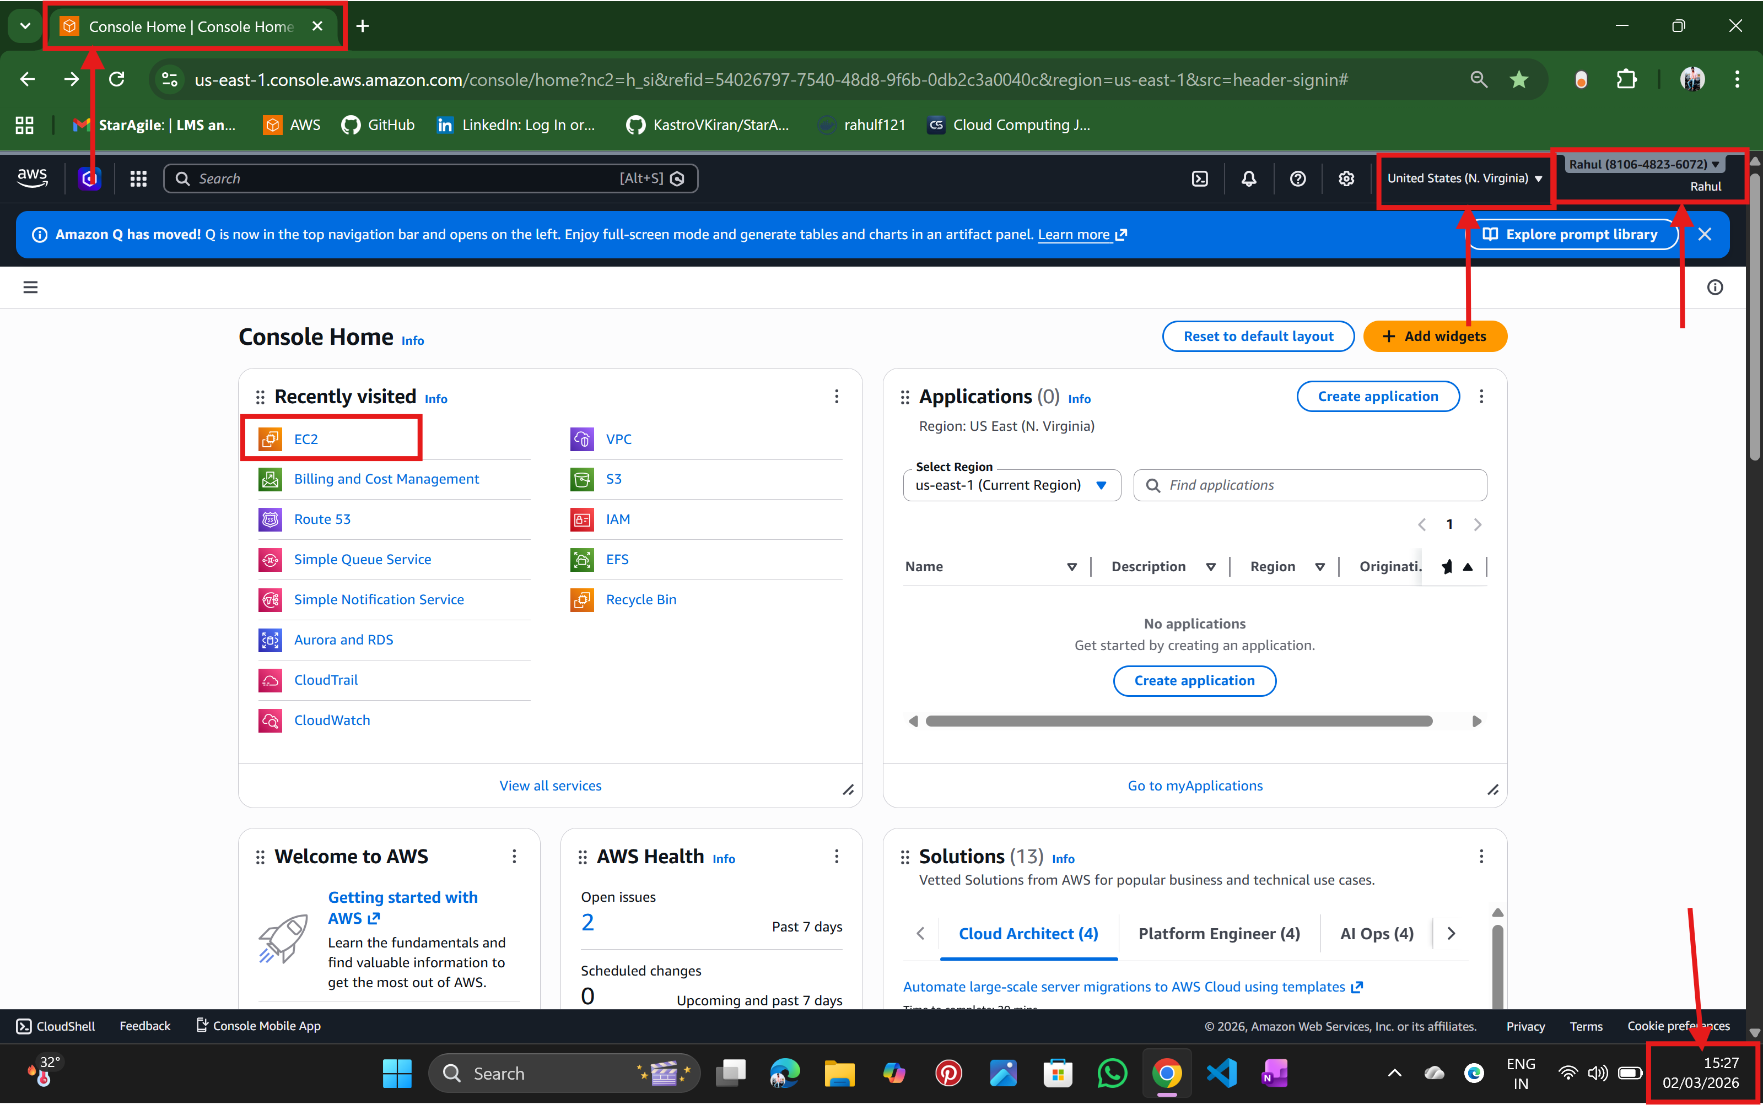

Step :2 create an instance
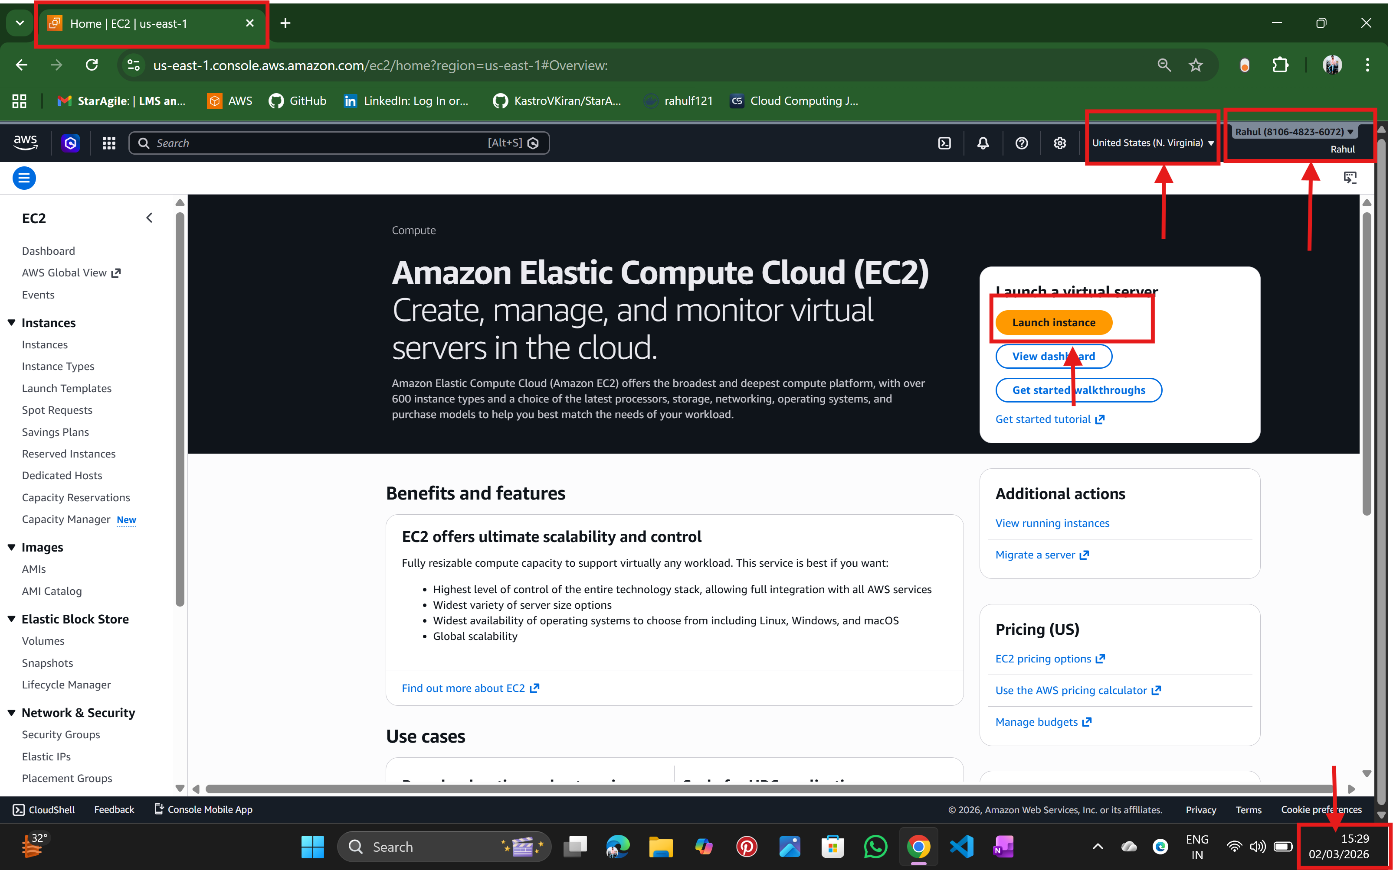

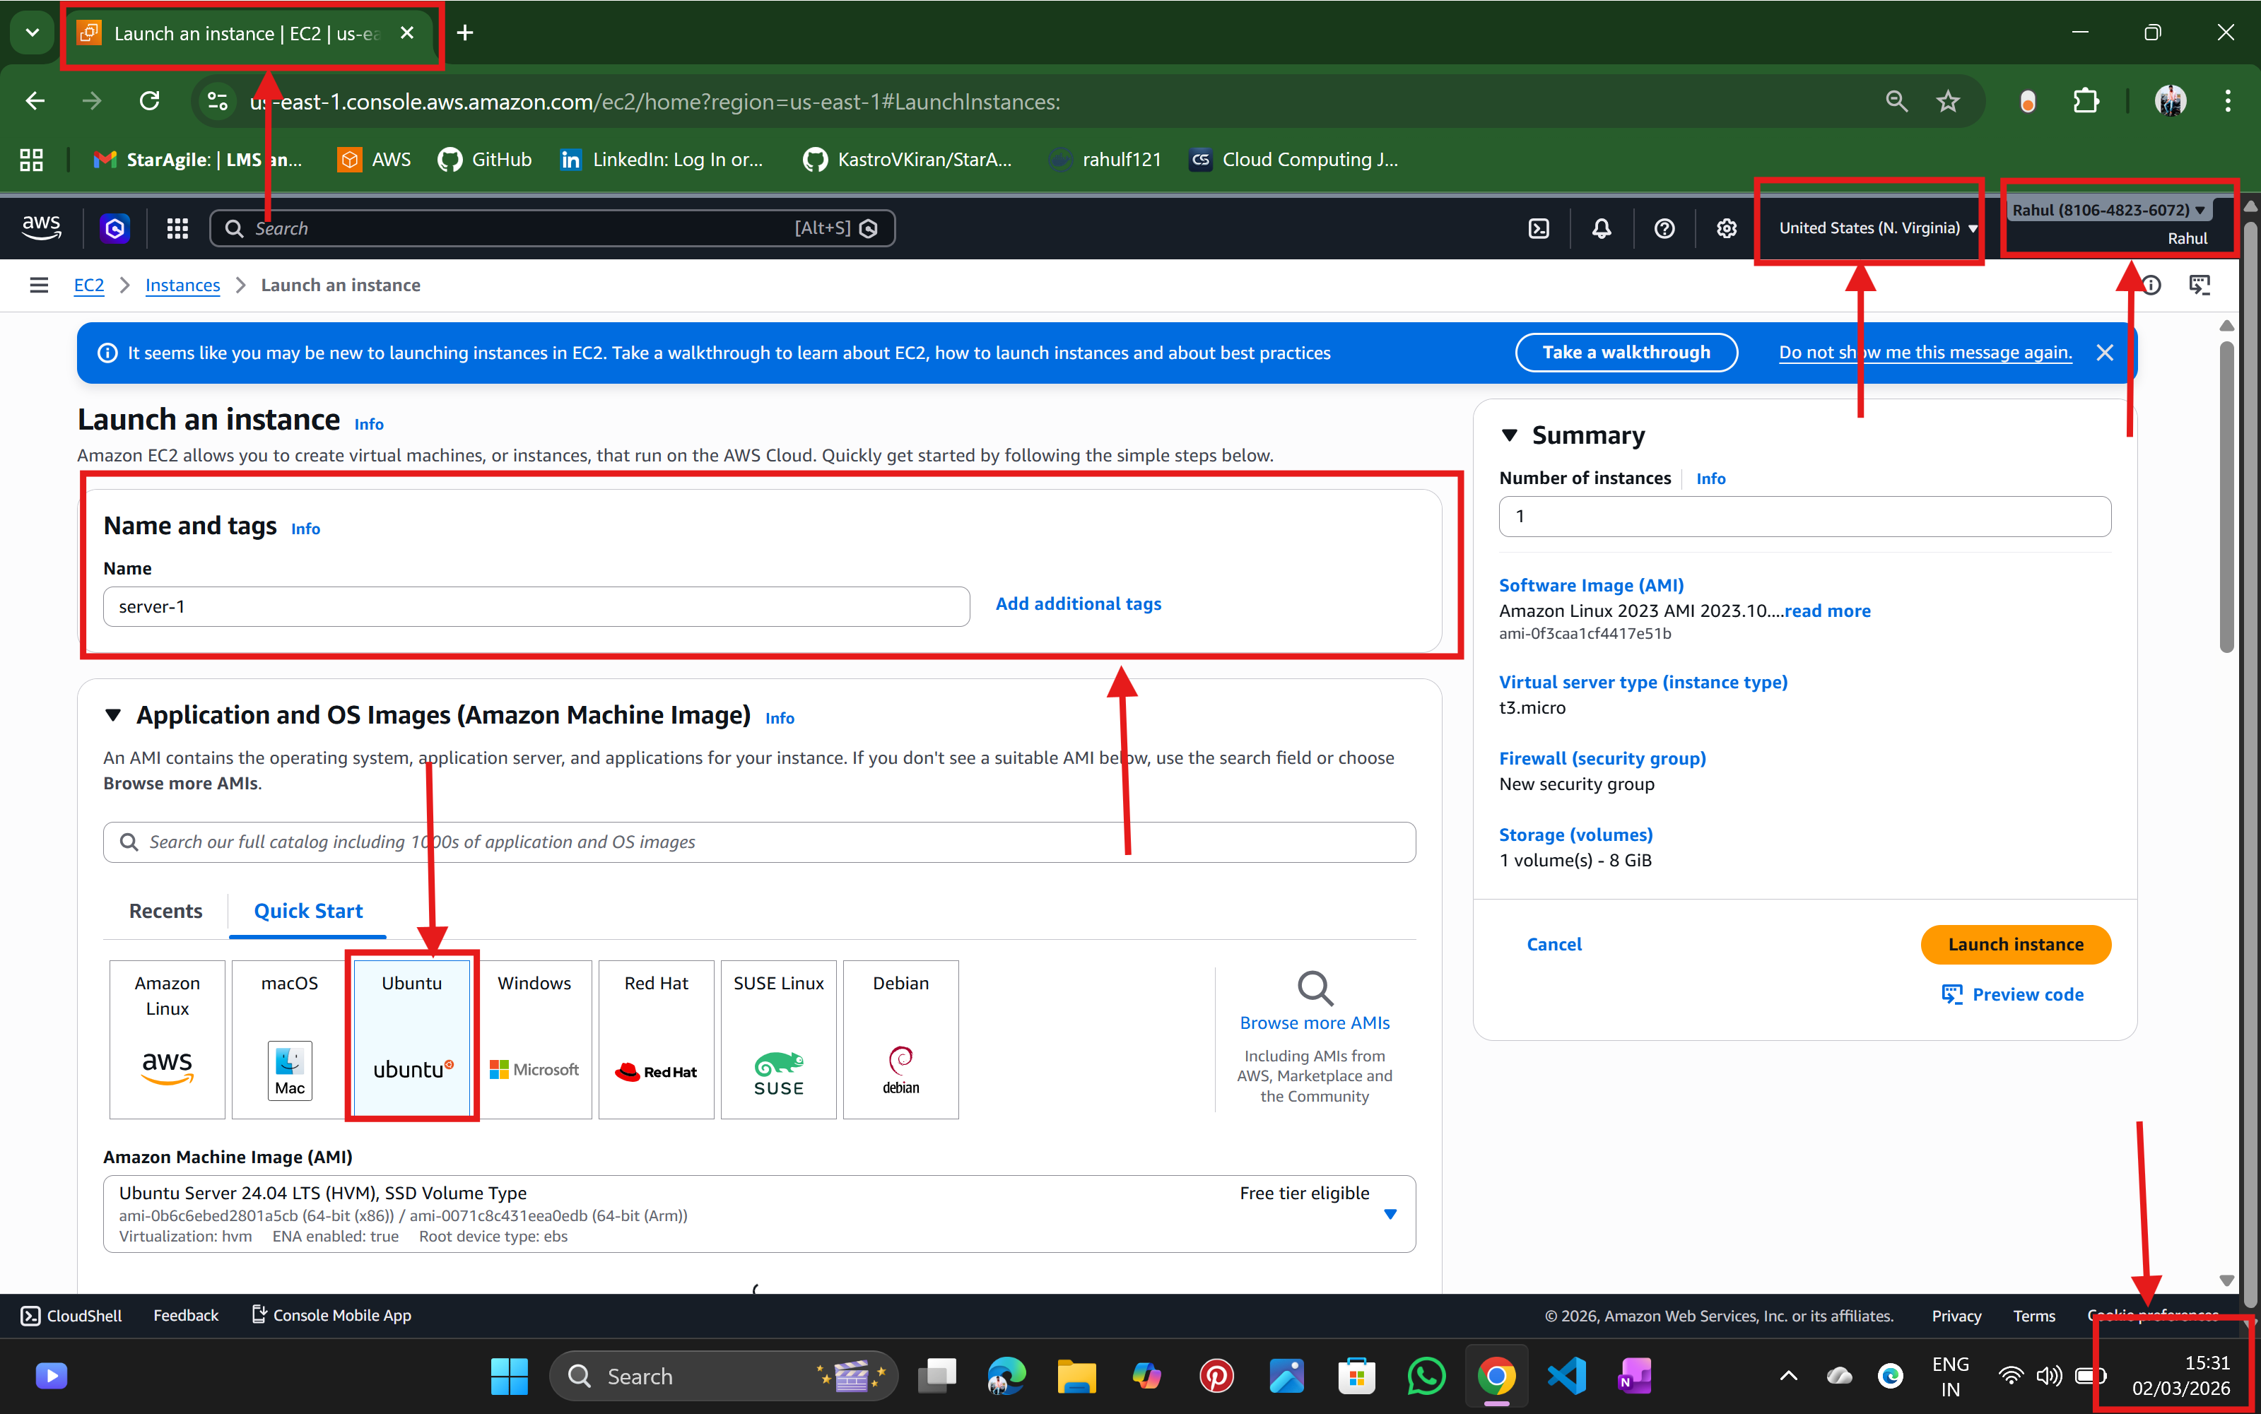
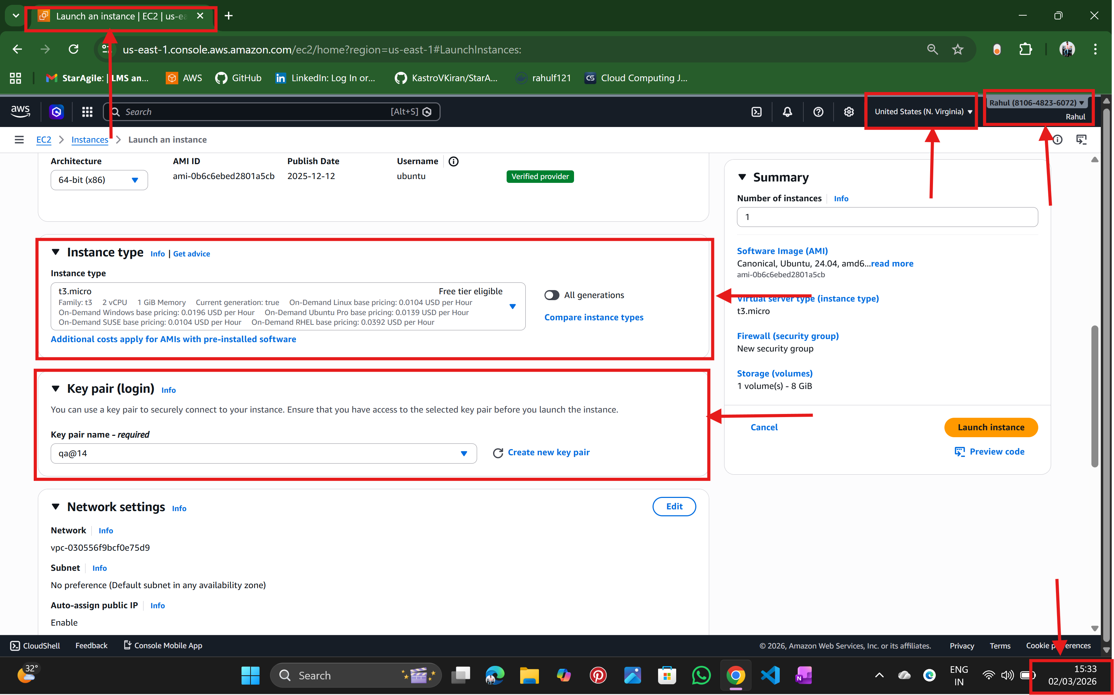

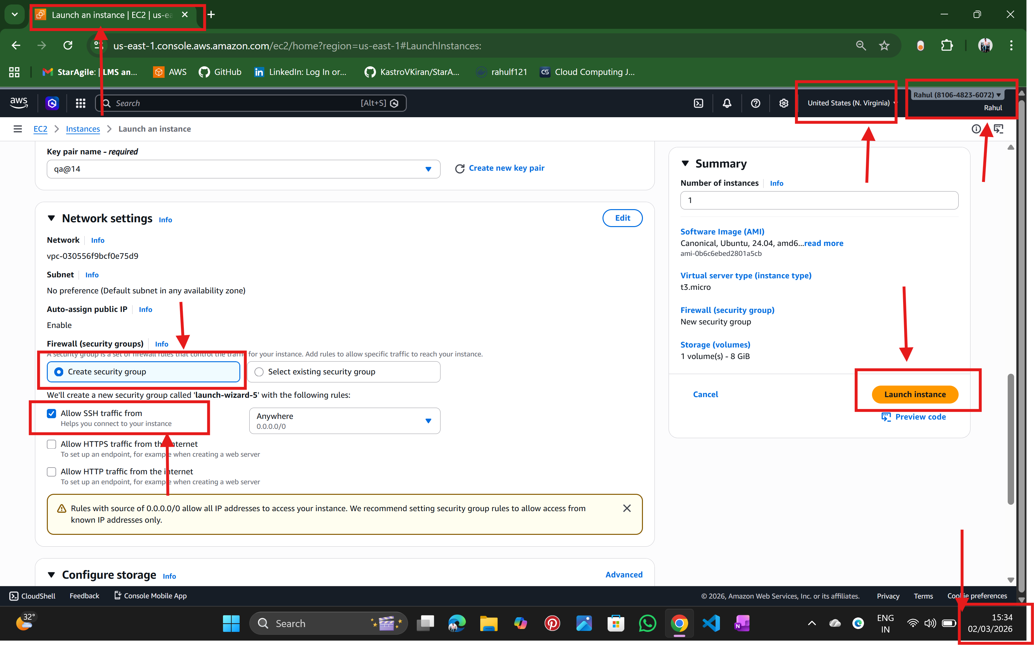
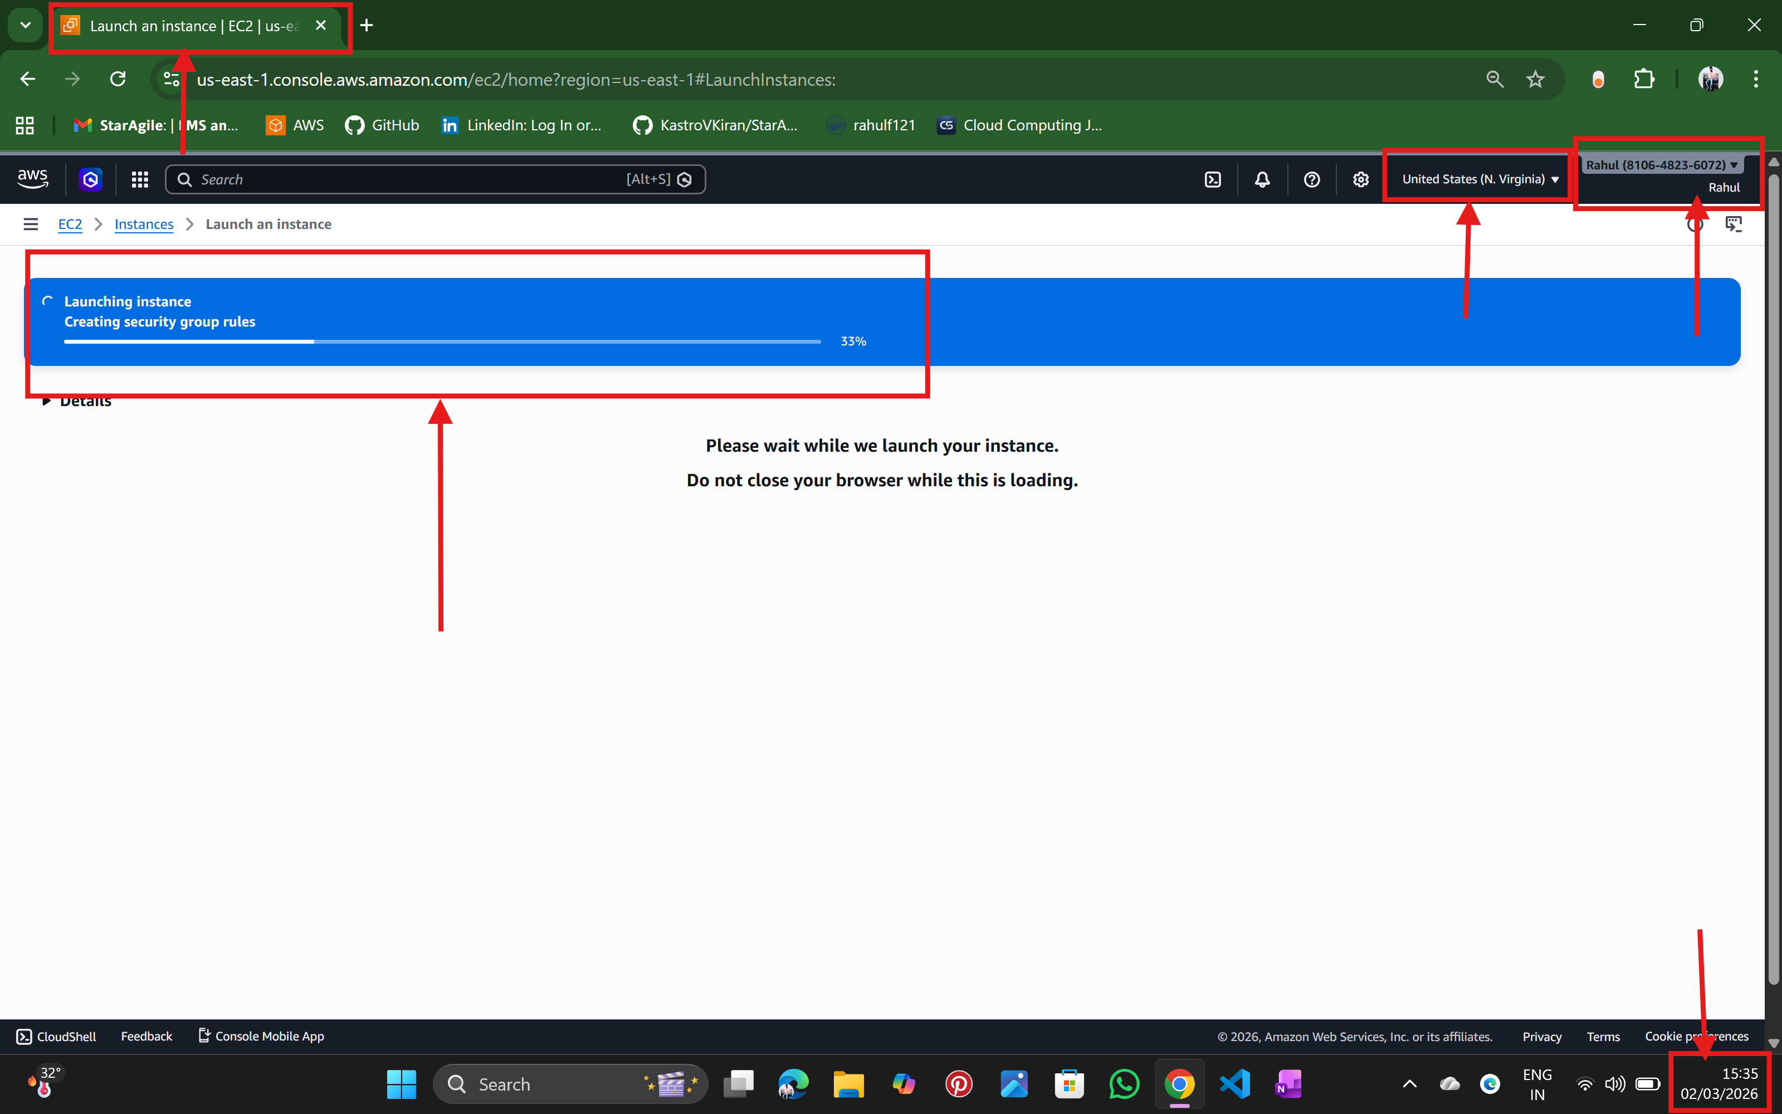

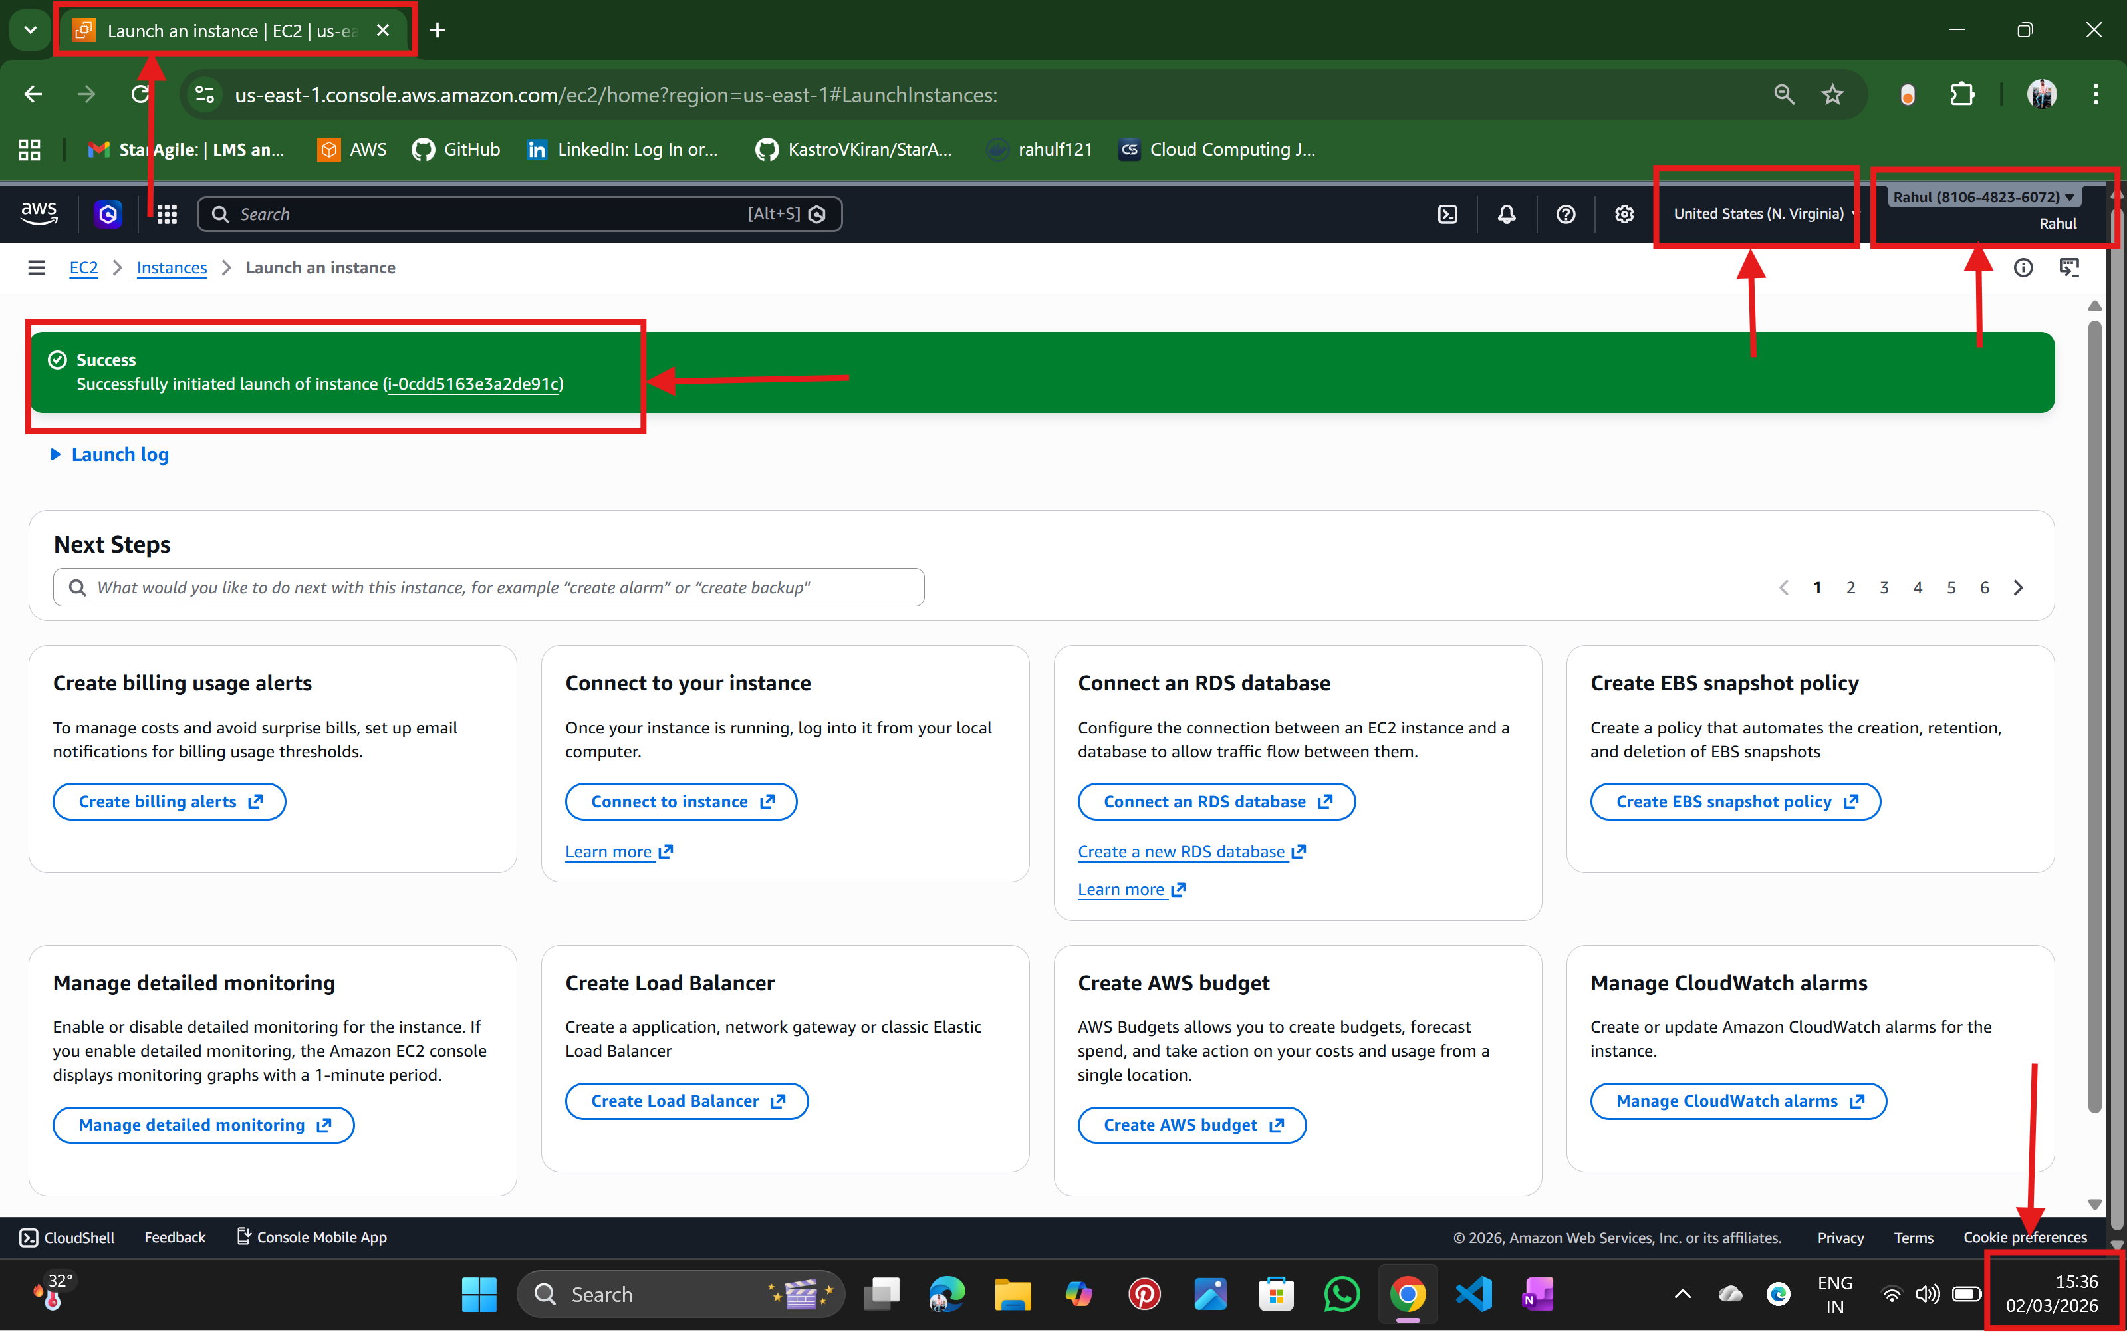

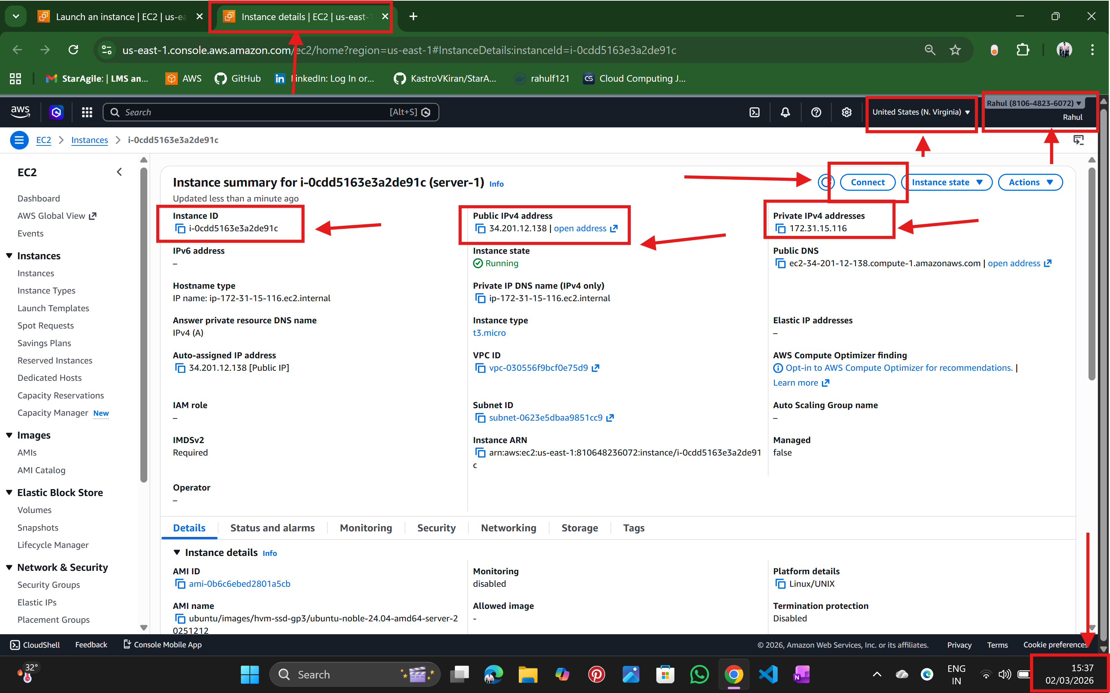

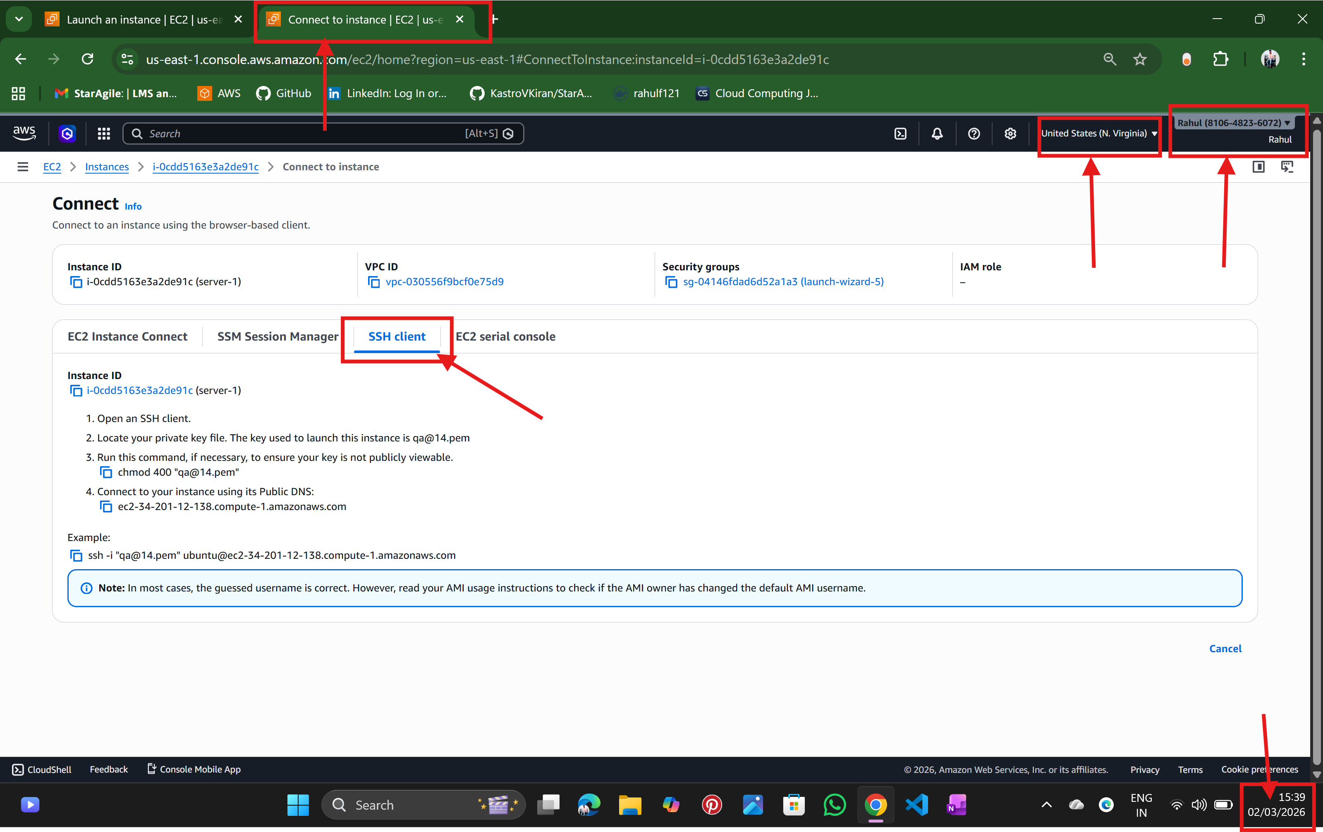

Step :3 Connect to Your EC2 Instance by using ssh client from local terminal
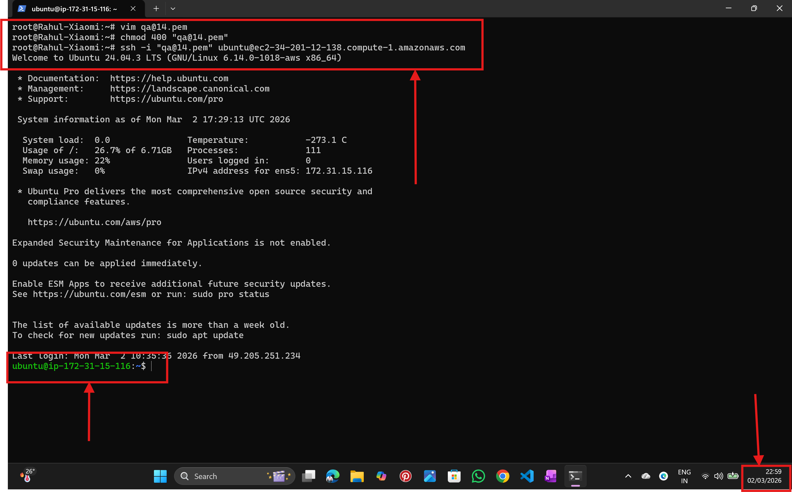

Step :4 Create a New User
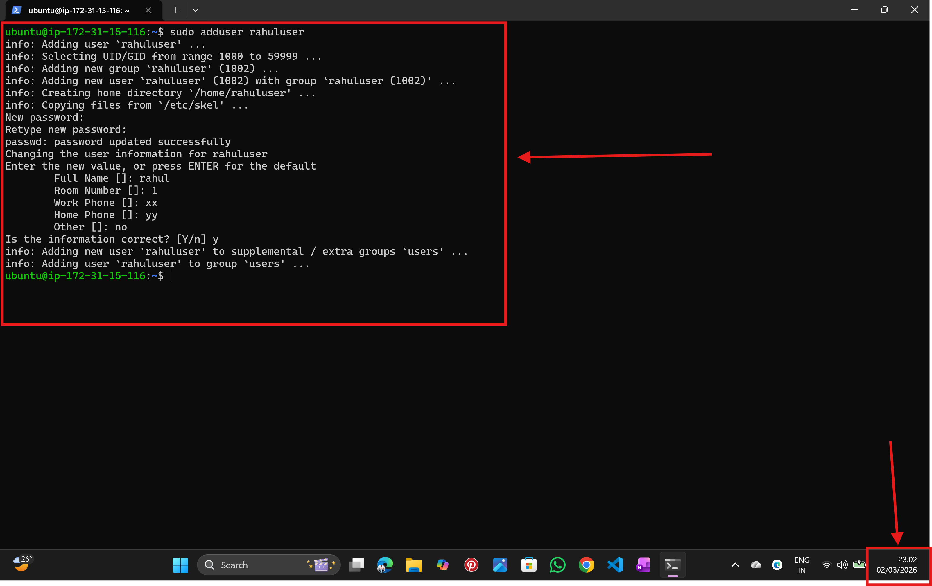

Step: 5 Give the User Sudo Privileges to have admin privileges
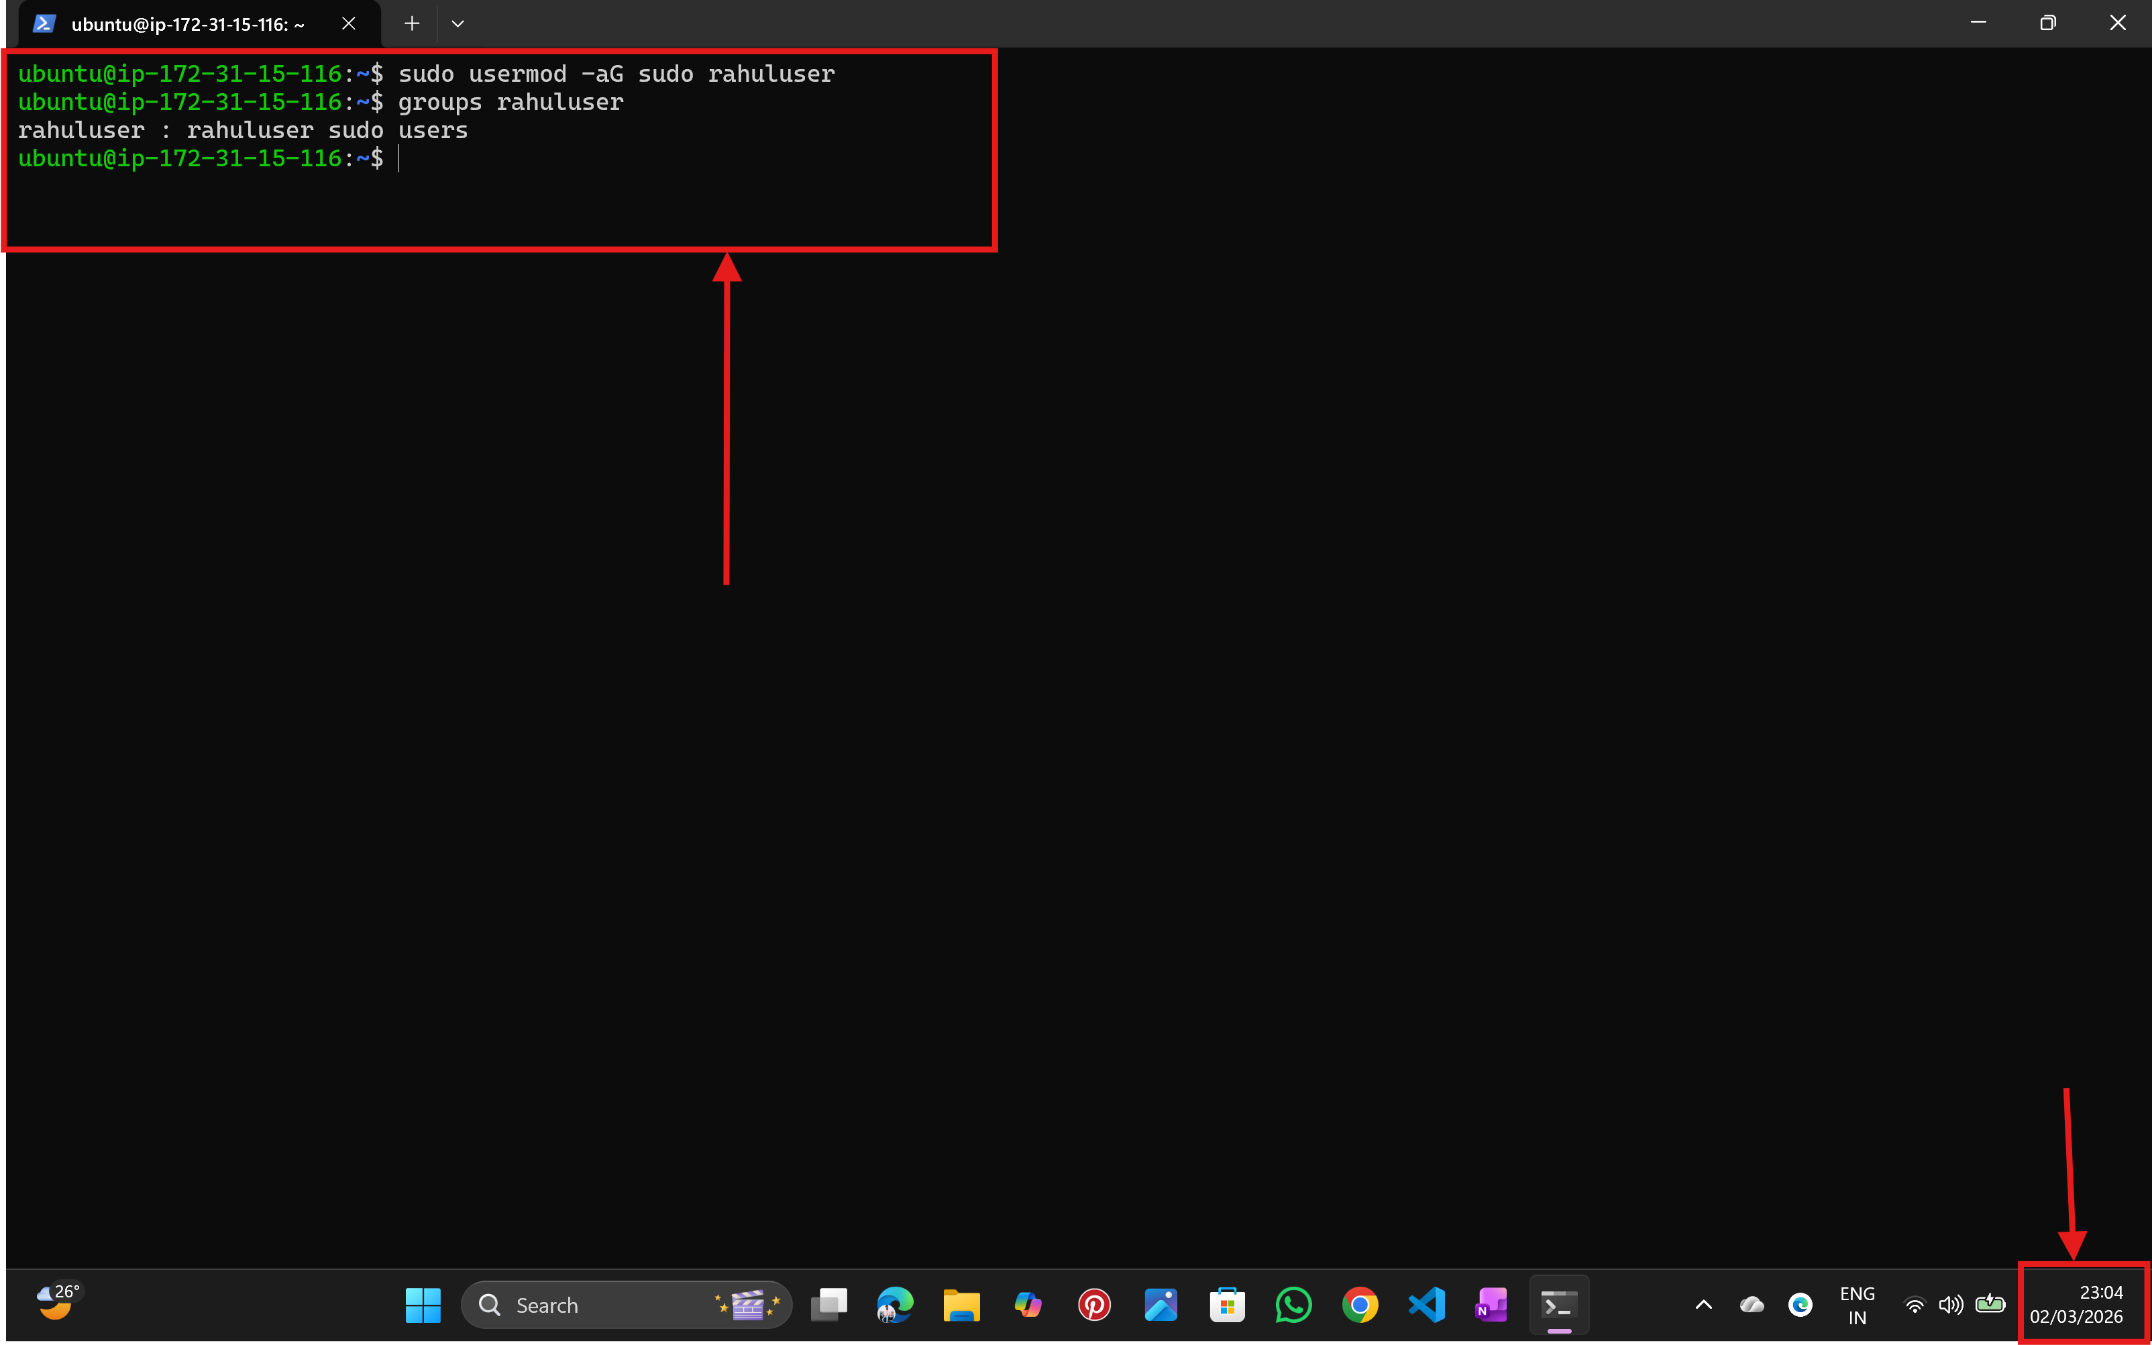

Step: 6 Create SSH Directory for the New User
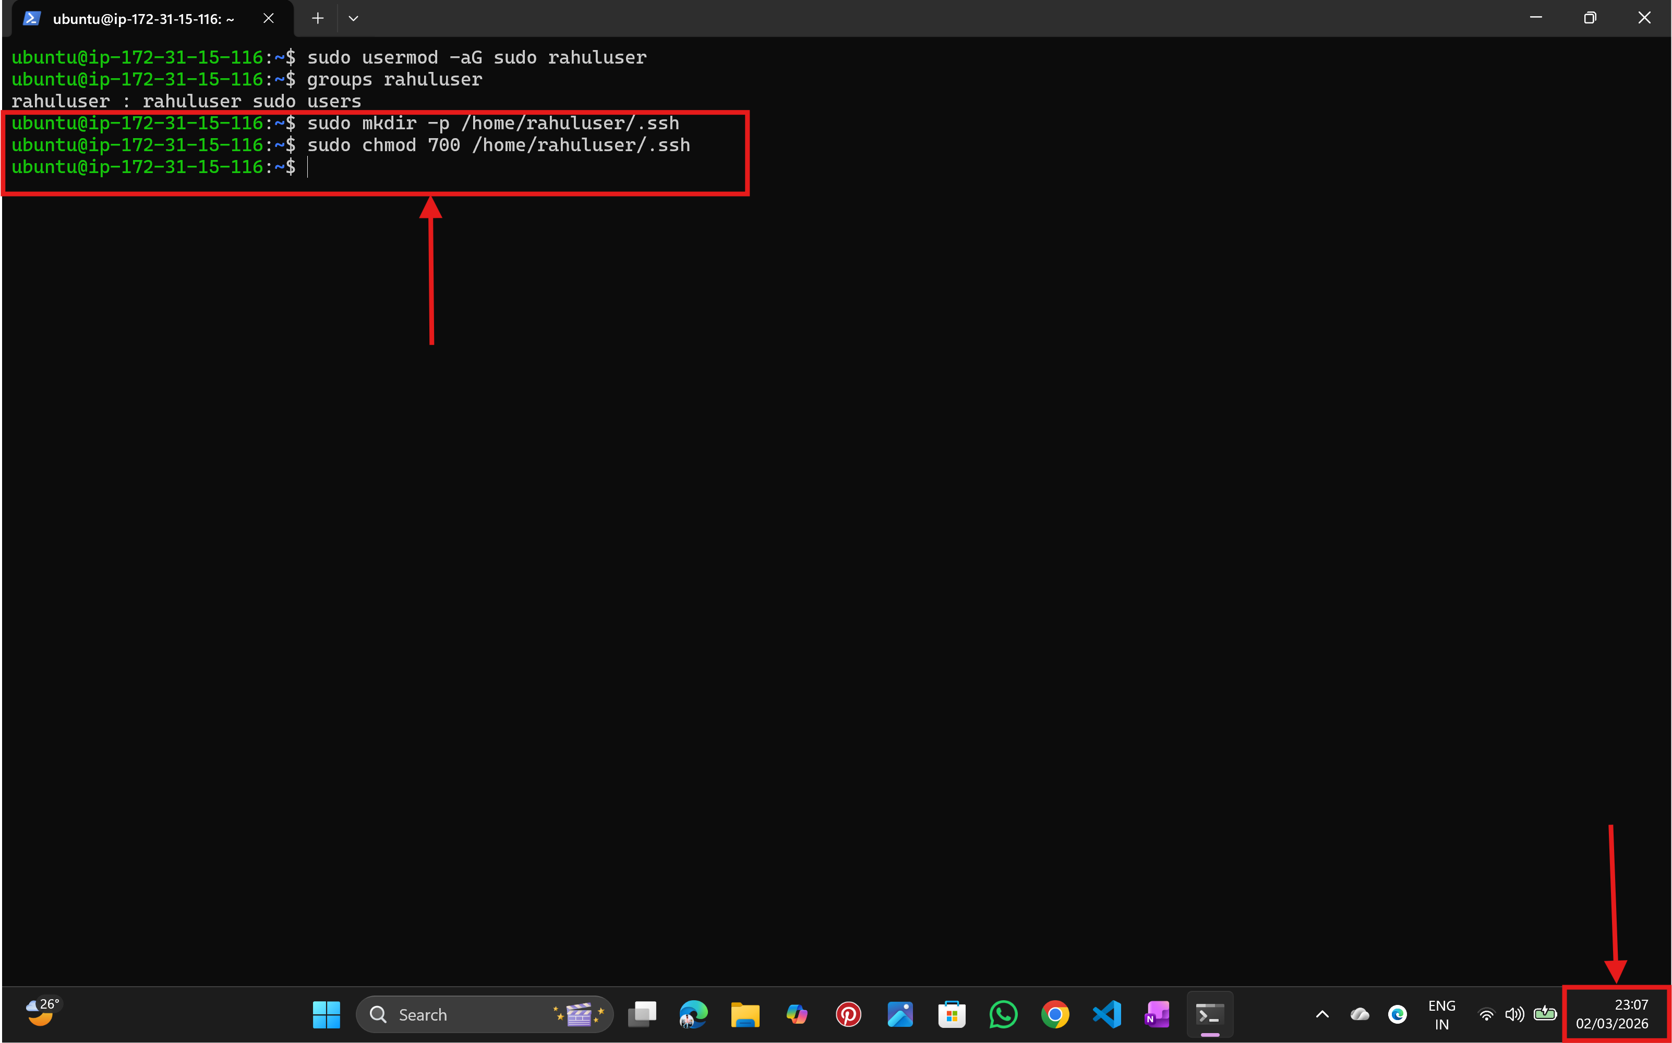

Step: 7 Now go back to local terminal for Generate SSH Key (On LOCAL Machine)
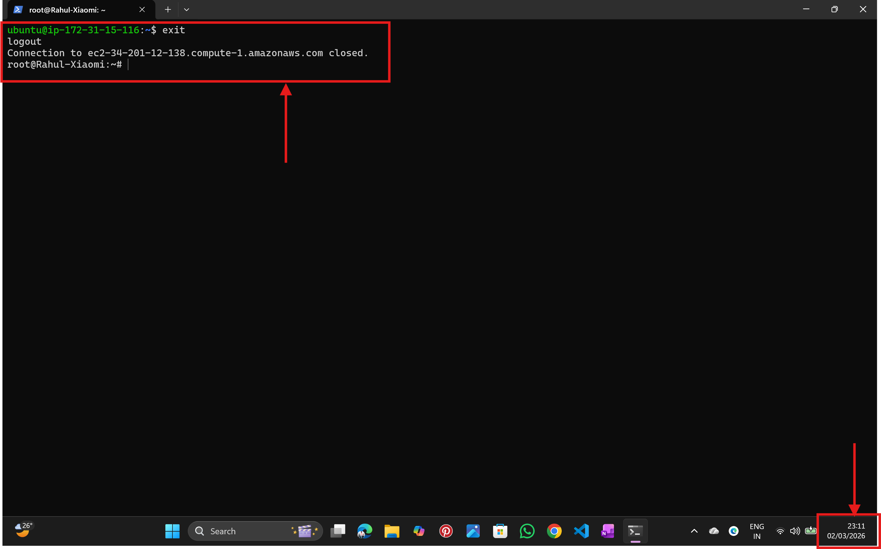
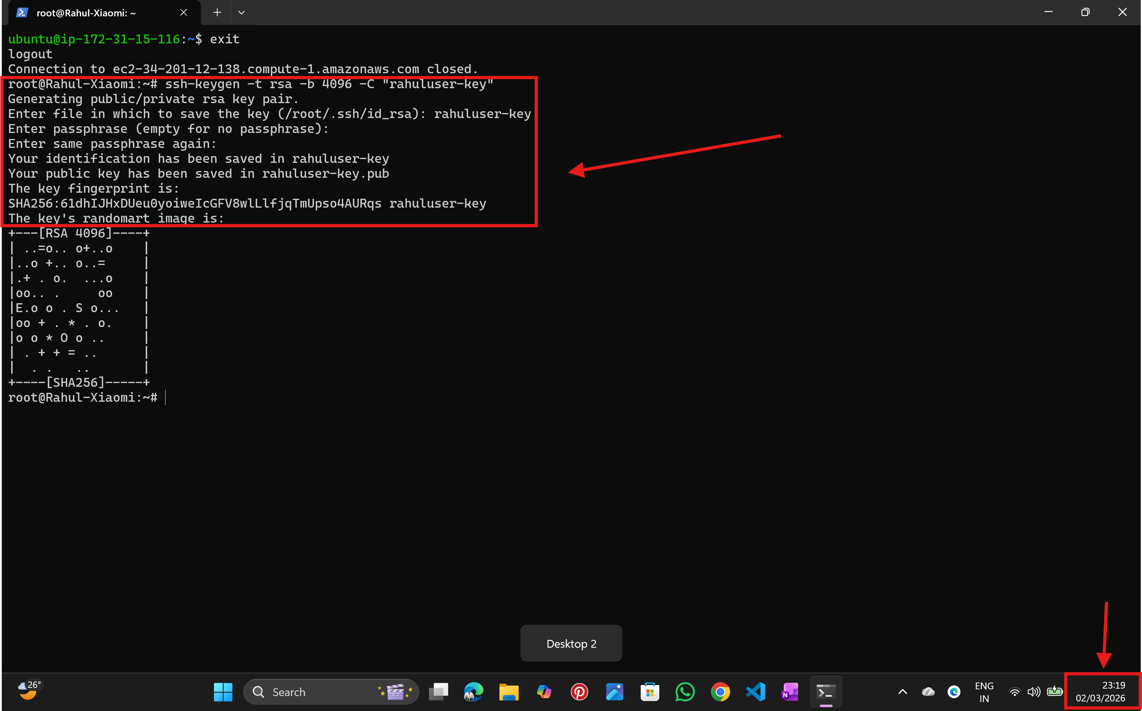

Step:8 Copy Public Key to EC2
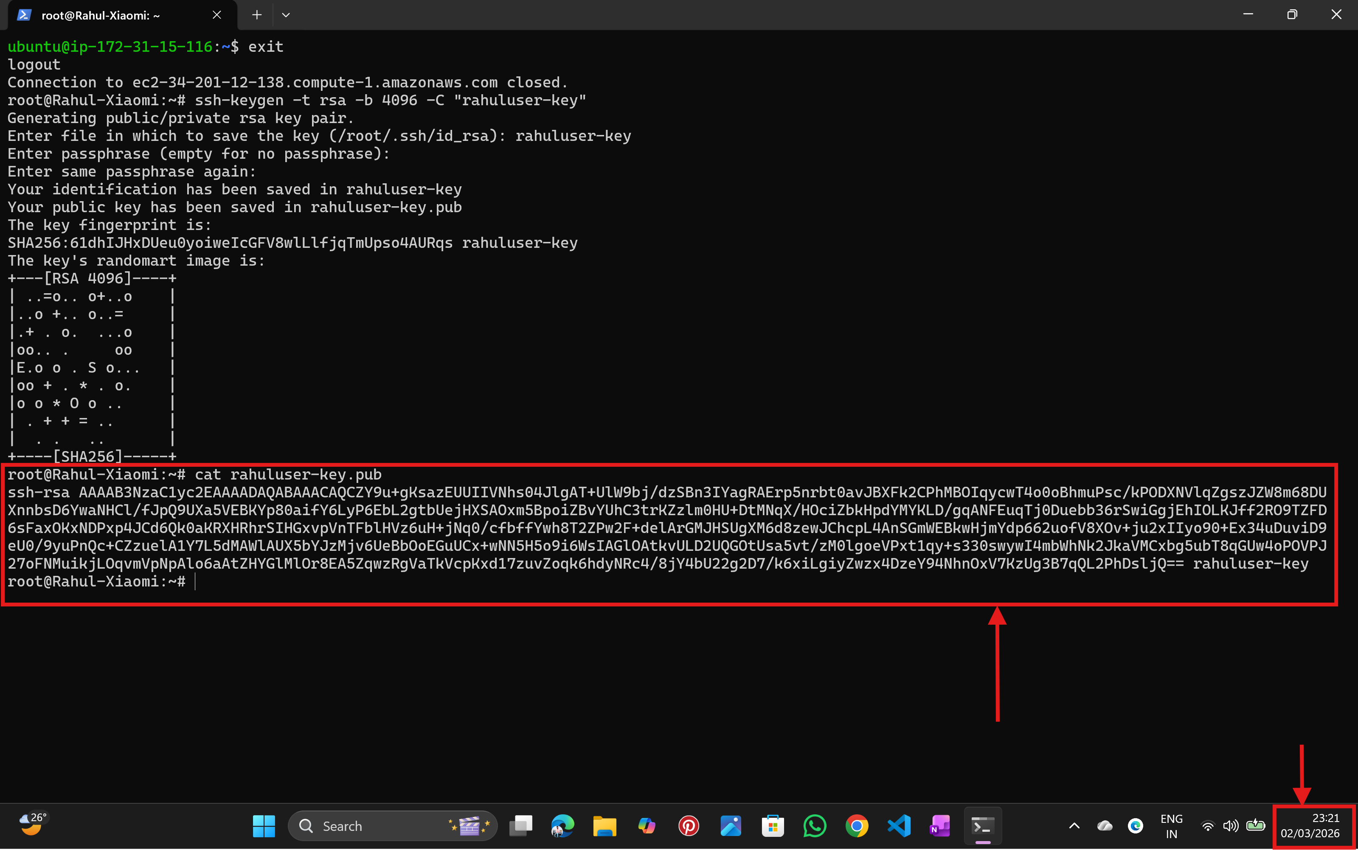

Step: 8 Add Public Key to Server by Login again as ubuntu
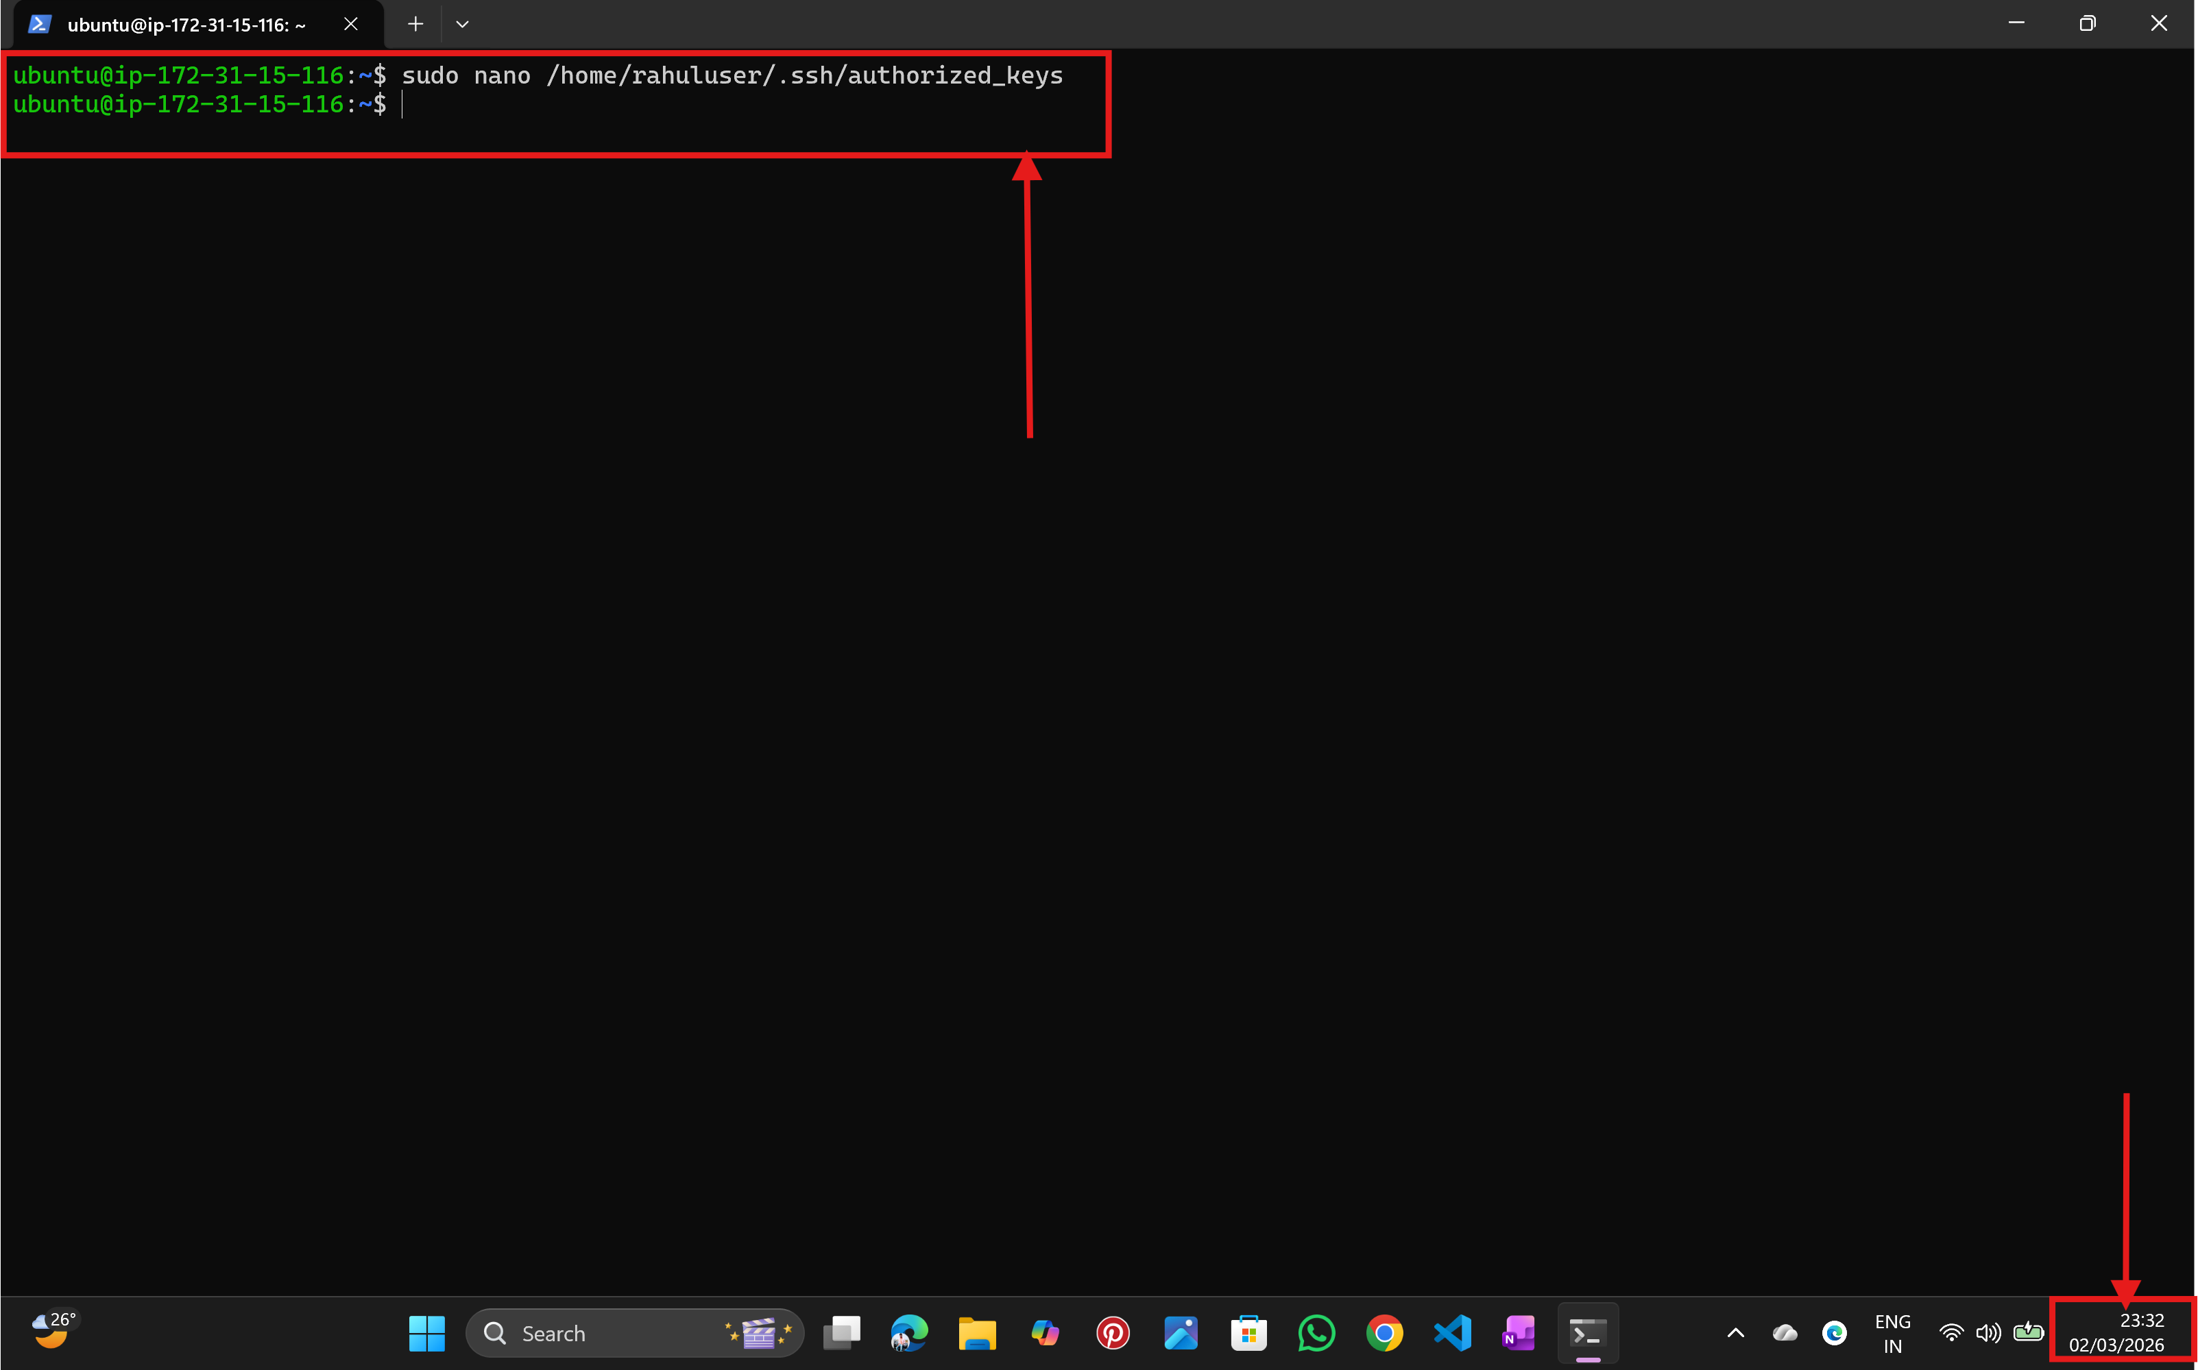

Step: 9 Fix Permissions
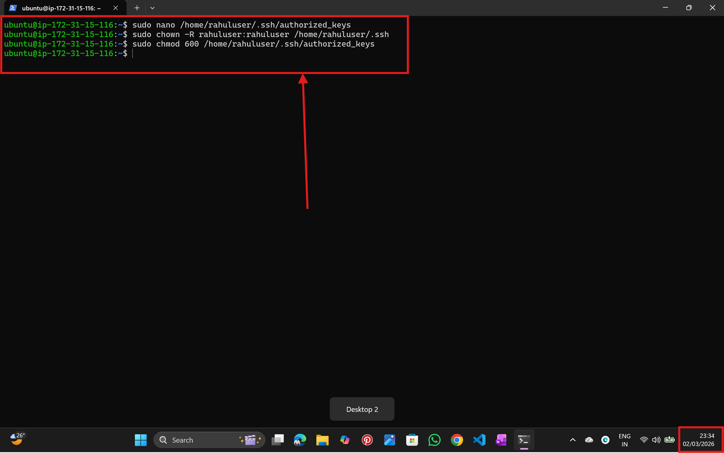

Step: 10 Test Login
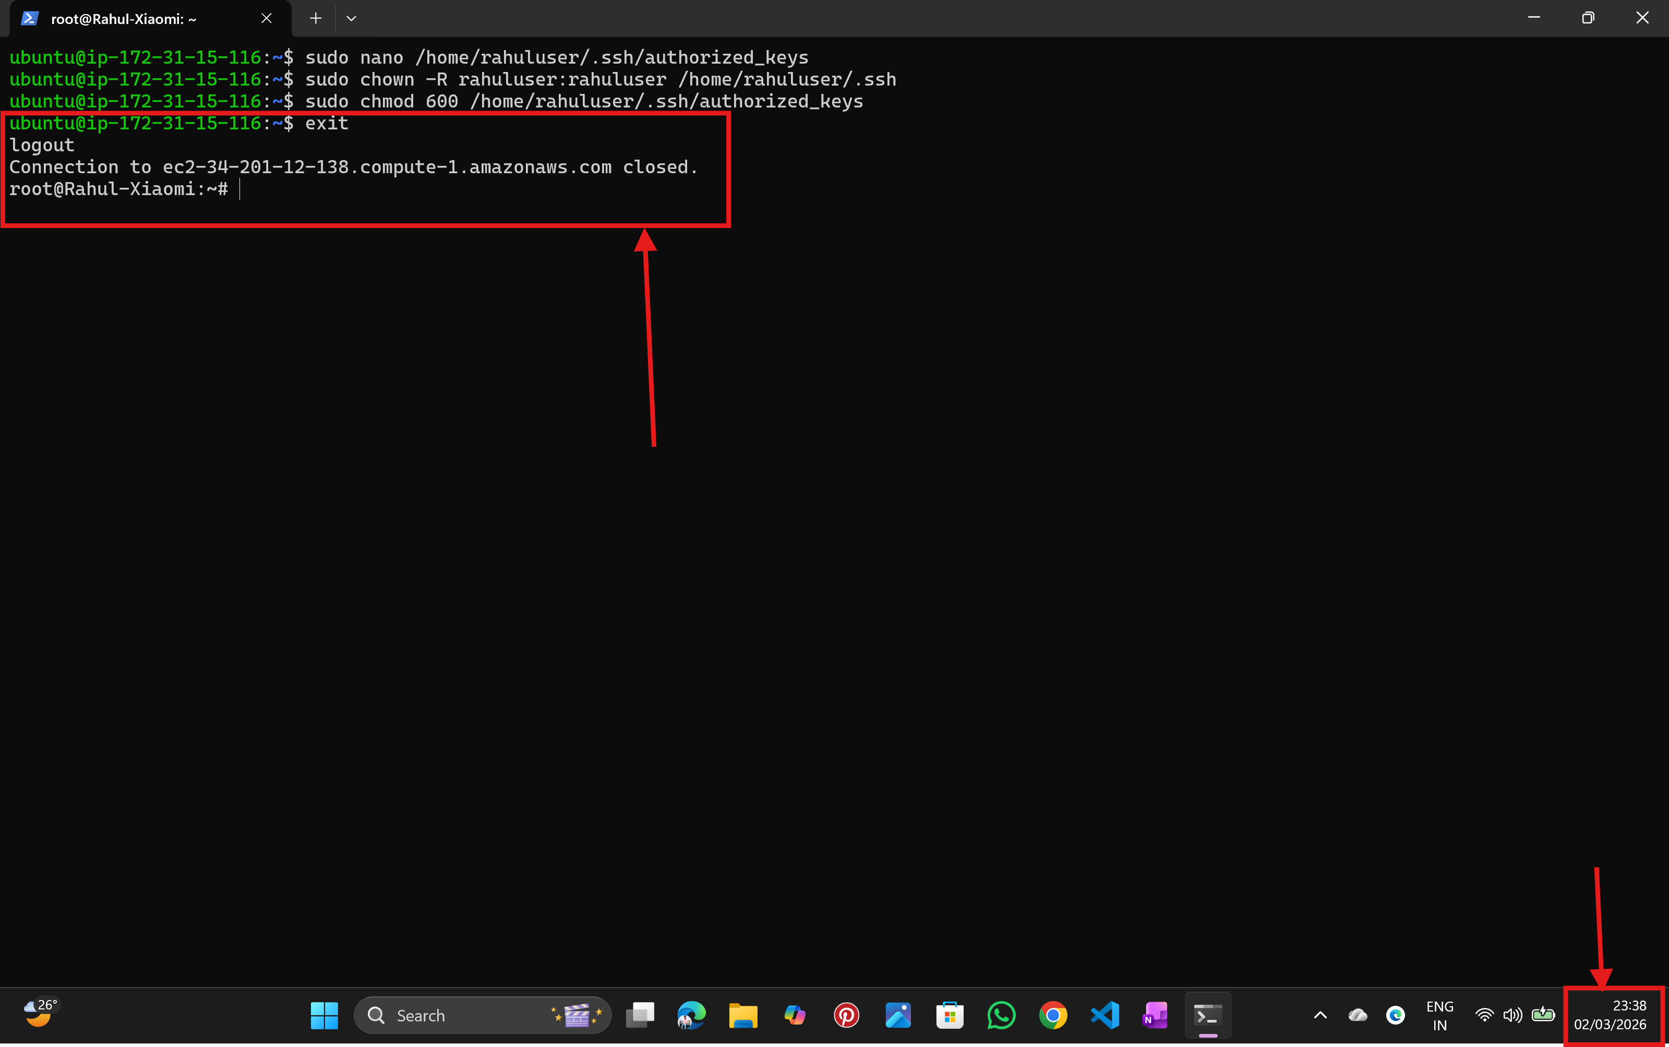
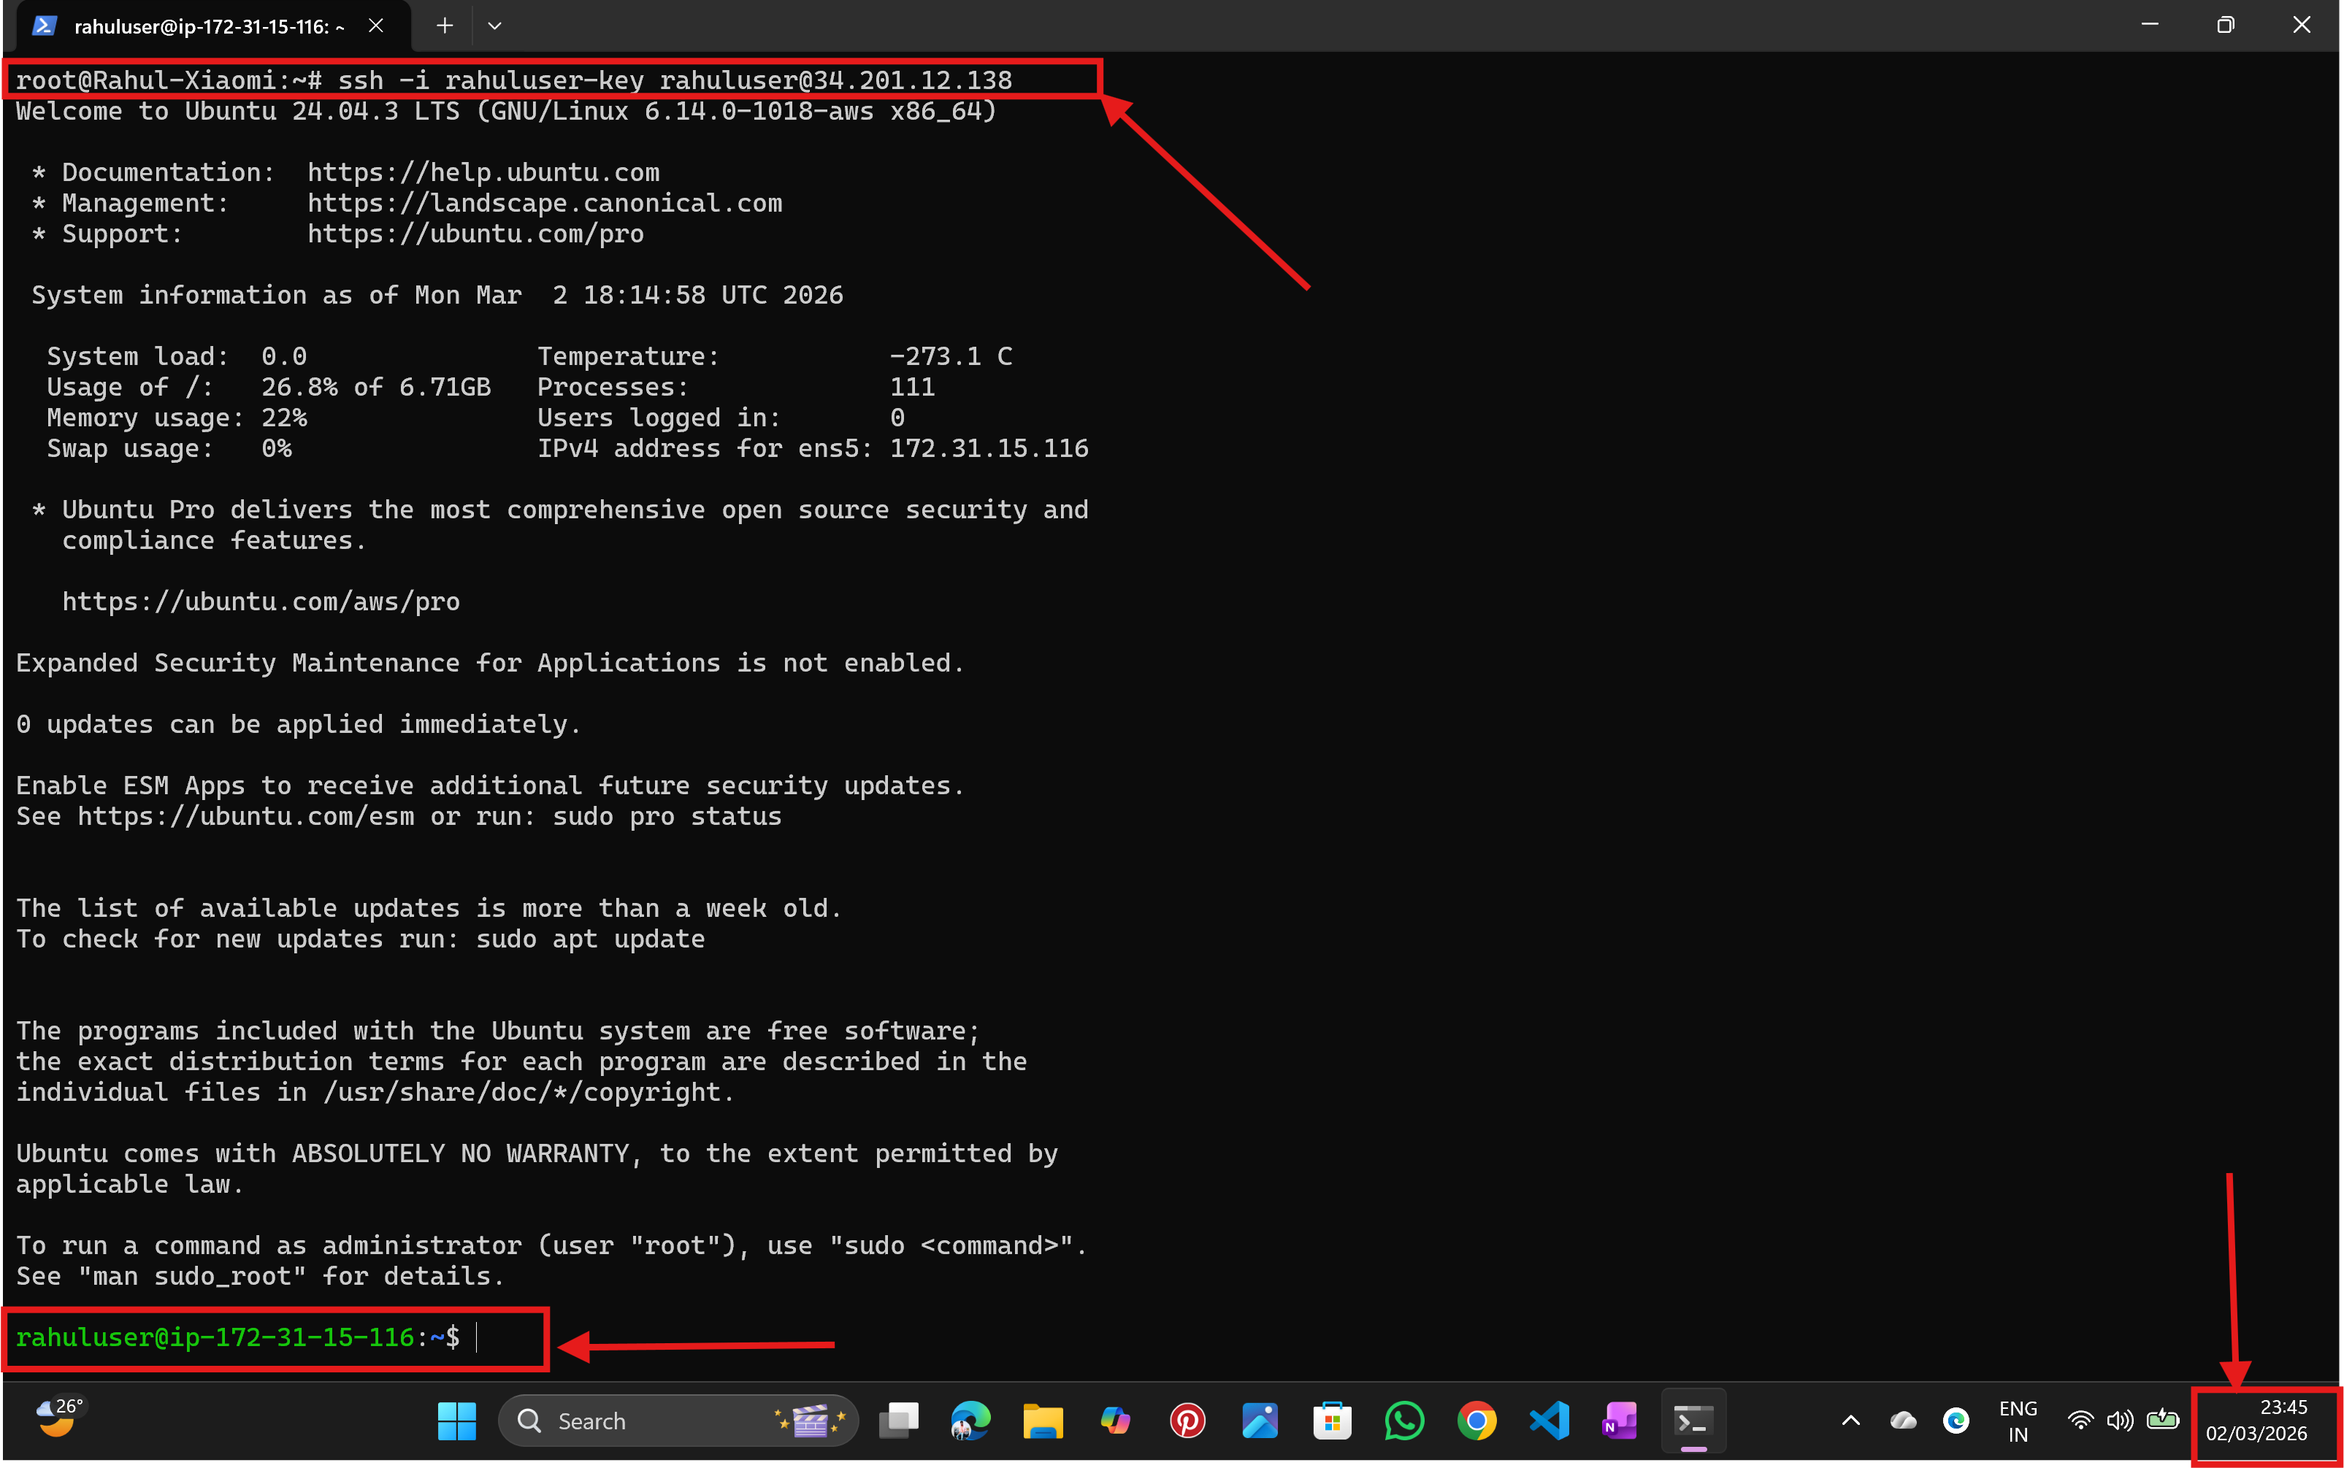
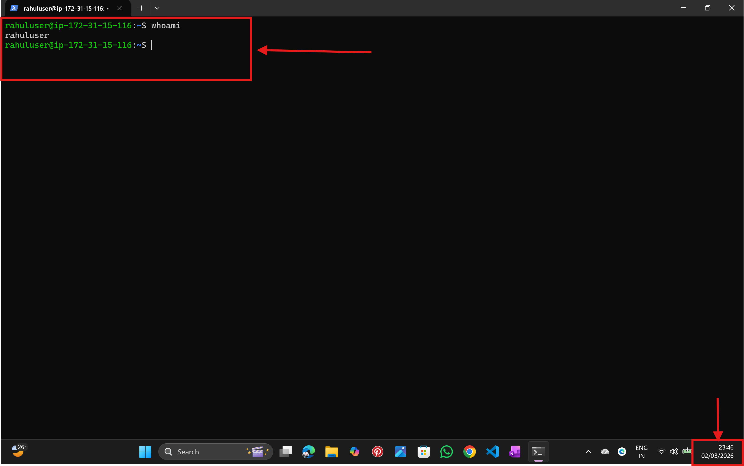

---------------------------------------------------------------END-----------------------------------------------------------------

NALATHATI RAHUL

